# C Loops

The looping can be defined as repeating the same process multiple times until a specific condition satisfies. There are three types of loops used in the C language. In this part of the tutorial, we are going to learn all the aspects of C loops.

## Why use loops in C language?

The looping simplifies the complex problems into the easy ones. It enables us to alter the flow of the program so that instead of writing the same code again and again, we can repeat the same code for a finite number of times. For example, if we need to print the first 10 natural numbers then, instead of using the printf statement 10 times, we can print inside a loop which runs up to 10 iterations.

### Advantage of loops in C

1) It provides code reusability.

2) Using loops, we do not need to write the same code again and again.

3) Using loops, we can traverse over the elements of data structures (array or linked lists).

## Types of C Loops

There are three types of loops in [C language](https://www.javatpoint.com/c-programming-language-tutorial) that is given below:

1. do while
2. while
3. for

### do-while loop in C

The do-while loop continues until a given condition satisfies. It is also called post tested loop. It is used when it is necessary to execute the loop at least once (mostly menu driven programs).

The syntax of [do-while loop in c language](https://www.javatpoint.com/do-while-loop-in-c) is given below:

1. do{
2. //code to be executed
3. }while(condition);

[Flowchart and Example of do-while loop](https://www.javatpoint.com/do-while-loop-in-c)

### while loop in C

The while loop in c is to be used in the scenario where we don't know the number of iterations in advance. The block of statements is executed in the while loop until the condition specified in the while loop is satisfied. It is also called a pre-tested loop.

The syntax of while loop in c language is given below:

1. while(condition){
2. //code to be executed
3. }

[Flowchart and Example of while loop](https://www.javatpoint.com/while-loop-in-c)

### for loop in C

The for loop is used in the case where we need to execute some part of the code until the given condition is satisfied. The for loop is also called as a per-tested loop. It is better to use for loop if the number of iteration is known in advance.

The syntax of for loop in c language is given below:

1. for(initialization;condition;incr/decr){
2. //code to be executed
3. }

[Flowchart and Example of for loop](https://www.javatpoint.com/for-loop-in-c)

# do while loop in C

The do while loop is a post tested loop. Using the do-while loop, we can repeat the execution of several parts of the statements. The do-while loop is mainly used in the case where we need to execute the loop at least once. The do-while loop is mostly used in menu-driven programs where the termination condition depends upon the end user.

#### do while loop syntax

The syntax of the C language do-while loop is given below:

1. do{
2. //code to be executed
3. }while(condition);

#### Example 1

1. #include<stdio.h>
2. #include<stdlib.h>
3. void main ()
4. {
5. char c;
6. int choice,dummy;
7. do{
8. printf("\n1. Print Hello\n2. Print Javatpoint\n3. Exit\n");
9. scanf("%d",&choice);
10. switch(choice)
11. {
12. case 1 :
13. printf("Hello");
14. break;
15. case 2:
16. printf("Javatpoint");
17. break;
18. case 3:
19. exit(0);
20. break;
21. default:
22. printf("please enter valid choice");
23. }
24. printf("do you want to enter more?");
25. scanf("%d",&dummy);
26. scanf("%c",&c);
27. }while(c=='y');
28. }

#### Output

1. Print Hello

2. Print Javatpoint

3. Exit

1

Hello

do you want to enter more?

y

1. Print Hello

2. Print Javatpoint

3. Exit

2

Javatpoint

do you want to enter more?

n

#### Flowchart of do while loop

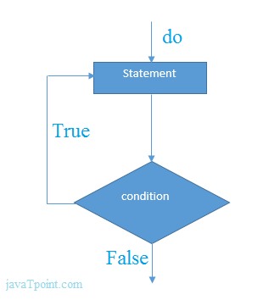

#### do while example

There is given the simple program of c language do while loop where we are printing the table of 1.

1. #include<stdio.h>
2. int main(){
3. int i=1;
4. do{
5. printf("%d \n",i);
6. i++;
7. }while(i<=10);
8. return 0;
9. }

#### Output

1

2

3

4

5

6

7

8

9

10

#### Program to print table for the given number using do while loop

1. #include<stdio.h>
2. int main(){
3. int i=1,number=0;
4. printf("Enter a number: ");
5. scanf("%d",&number);
6. do{
7. printf("%d \n",(number*i));
8. i++;
9. }while(i<=10);
10. return 0;
11. }

#### Output

Enter a number: 5

5

10

15

20

25

30

35

40

45

50

Enter a number: 10

10

20

30

40

50

60

70

80

90

100

#### Infinitive do while loop

The do-while loop will run infinite times if we pass any non-zero value as the conditional expression.

1. do{
2. //statement
3. }while(1);

# while loop in C

While loop is also known as a pre-tested loop. In general, a while loop allows a part of the code to be executed multiple times depending upon a given boolean condition. It can be viewed as a repeating if statement. The while loop is mostly used in the case where the number of iterations is not known in advance.

#### Syntax of while loop in C language

The syntax of while loop in c language is given below:

1. while(condition){
2. //code to be executed
3. }

#### Flowchart of while loop in C

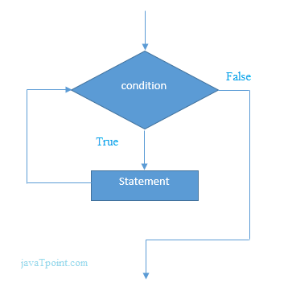

## Example of the while loop in C language

Let's see the simple program of while loop that prints table of 1.

1. #include<stdio.h>
2. int main(){
3. int i=1;
4. while(i<=10){
5. printf("%d \n",i);
6. i++;
7. }
8. return 0;
9. }

#### Output

1

2

3

4

5

6

7

8

9

10

## Program to print table for the given number using while loop in C

1. #include<stdio.h>
2. int main(){
3. int i=1,number=0,b=9;
4. printf("Enter a number: ");
5. scanf("%d",&number);
6. while(i<=10){
7. printf("%d \n",(number*i));
8. i++;
9. }
10. return 0;
11. }

#### Output

Enter a number: 50

50

100

150

200

250

300

350

400

450

500

Enter a number: 100

100

200

300

400

500

600

700

800

900

1000

## Properties of while loop

* A conditional expression is used to check the condition. The statements defined inside the while loop will repeatedly execute until the given condition fails.
* The condition will be true if it returns 0. The condition will be false if it returns any non-zero number.
* In while loop, the condition expression is compulsory.
* Running a while loop without a body is possible.
* We can have more than one conditional expression in while loop.
* If the loop body contains only one statement, then the braces are optional.

#### Example 1

1. #include<stdio.h>
2. void main ()
3. {
4. int j = 1;
5. while(j+=2,j<=10)
6. {
7. printf("%d ",j);
8. }
9. printf("%d",j);
10. }

#### Output

3 5 7 9 11

#### Example 2

1. #include<stdio.h>
2. void main ()
3. {
4. while()
5. {
6. printf("hello Javatpoint");
7. }
8. }

#### Output

compile time error: while loop can't be empty

#### Example 3

1. #include<stdio.h>
2. void main ()
3. {
4. int x = 10, y = 2;
5. while(x+y-1)
6. {
7. printf("%d %d",x--,y--);
8. }
9. }

#### Output

infinite loop

## Infinitive while loop in C

If the expression passed in while loop results in any non-zero value then the loop will run the infinite number of times.

1. while(1){
2. //statement
3. }

# for loop in C

The for loop in C language is used to iterate the statements or a part of the program several times. It is frequently used to traverse the data structures like the array and linked list.

### Syntax of for loop in C

The syntax of for loop in c language is given below:

1. for(Expression 1; Expression 2; Expression 3){
2. //code to be executed
3. }

### Flowchart of for loop in C

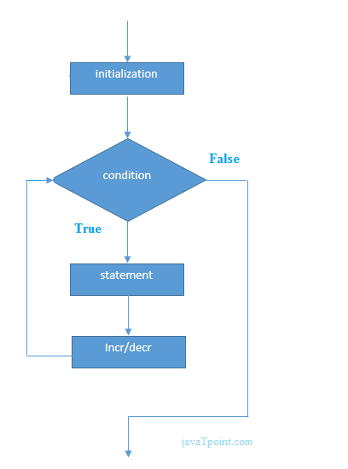

### C for loop Examples

Let's see the simple program of for loop that prints table of 1.

1. #include<stdio.h>
2. int main(){
3. int i=0;
4. for(i=1;i<=10;i++){
5. printf("%d \n",i);
6. }
7. return 0;
8. }

Output

1

2

3

4

5

6

7

8

9

10

### C Program: Print table for the given number using C for loop

1. #include<stdio.h>
2. int main(){
3. int i=1,number=0;
4. printf("Enter a number: ");
5. scanf("%d",&number);
6. for(i=1;i<=10;i++){
7. printf("%d \n",(number*i));
8. }
9. return 0;
10. }

Output

Enter a number: 2

2

4

6

8

10

12

14

16

18

20

Enter a number: 1000

1000

2000

3000

4000

5000

6000

7000

8000

9000

10000

### Properties of Expression 1

* The expression represents the initialization of the loop variable.
* We can initialize more than one variable in Expression 1.
* Expression 1 is optional.
* In C, we can not declare the variables in Expression 1. However, It can be an exception in some compilers.

Example 1

1. #include <stdio.h>
2. int main()
3. {
4. int a,b,c;
5. for(a=0,b=12,c=23;a<2;a++)
6. {
7. printf("%d ",a+b+c);
8. }
9. }

Output

35 36

Example 2

1. #include <stdio.h>
2. int main()
3. {
4. int i=1;
5. for(;i<5;i++)
6. {
7. printf("%d ",i);
8. }
9. }

Output

1 2 3 4

### Properties of Expression 2

* Expression 2 is a conditional expression. It checks for a specific condition to be satisfied. If it is not, the loop is terminated.
* Expression 2 can have more than one condition. However, the loop will iterate until the last condition becomes false. Other conditions will be treated as statements.
* Expression 2 is optional.
* Expression 2 can perform the task of expression 1 and expression 3. That is, we can initialize the variable as well as update the loop variable in expression 2 itself.
* We can pass zero or non-zero value in expression 2. However, in C, any non-zero value is true, and zero is false by default.

Example 1

1. #include <stdio.h>
2. int main()
3. {
4. int i;
5. for(i=0;i<=4;i++)
6. {
7. printf("%d ",i);
8. }
9. }

output

0 1 2 3 4

Example 2

1. #include <stdio.h>
2. int main()
3. {
4. int i,j,k;
5. for(i=0,j=0,k=0;i<4,k<8,j<10;i++)
6. {
7. printf("%d %d %d\n",i,j,k);
8. j+=2;
9. k+=3;
10. }
11. }

Output

0 0 0

1 2 3

2 4 6

3 6 9

4 8 12

Example 3

1. #include <stdio.h>
2. int main()
3. {
4. int i;
5. for(i=0;;i++)
6. {
7. printf("%d",i);
8. }
9. }

Output

infinite loop

#### Properties of Expression 3

* Expression 3 is used to update the loop variable.
* We can update more than one variable at the same time.
* Expression 3 is optional.

Example 1

1. #include<stdio.h>
2. void main ()
3. {
4. int i=0,j=2;
5. for(i = 0;i<5;i++,j=j+2)
6. {
7. printf("%d %d\n",i,j);
8. }
9. }

Output

0 2

1 4

2 6

3 8

4 10

### Loop body

The braces {} are used to define the scope of the loop. However, if the loop contains only one statement, then we don't need to use braces. A loop without a body is possible. The braces work as a block separator, i.e., the value variable declared inside for loop is valid only for that block and not outside. Consider the following example.

1. #include<stdio.h>
2. void main ()
3. {
4. int i;
5. for(i=0;i<10;i++)
6. {
7. int i = 20;
8. printf("%d ",i);
9. }
10. }

Output

20 20 20 20 20 20 20 20 20 20

### Infinitive for loop in C

To make a for loop infinite, we need not give any expression in the syntax. Instead of that, we need to provide two semicolons to validate the syntax of the for loop. This will work as an infinite for loop.

1. #include<stdio.h>
2. void main ()
3. {
4. for(;;)
5. {
6. printf("welcome to javatpoint");
7. }
8. }

If you run this program, you will see above statement infinite times.

# Nested Loops in C

C supports nesting of loops in C. Nesting of loops is the feature in C that allows the looping of statements inside another loop. Let's observe an example of nesting loops in C.

Any number of loops can be defined inside another loop, i.e., there is no restriction for defining any number of loops. The nesting level can be defined at n times. You can define any type of loop inside another loop; for example, you can define 'while' loop inside a 'for' loop.

Syntax of Nested loop

1. Outer_loop
2. {
3. Inner_loop
4. {
5. // inner loop statements.
6. }
7. // outer loop statements.
8. }

Outer_loop and Inner_loop are the valid loops that can be a 'for' loop, 'while' loop or 'do-while' loop.

Nested for loop

The nested for loop means any type of loop which is defined inside the 'for' loop.

1. for (initialization; condition; update)
2. {
3. for(initialization; condition; update)
4. {
5. // inner loop statements.
6. }
7. // outer loop statements.
8. }

Example of nested for loop

1. #include <stdio.h>
2. int main()
3. {
4. int n;// variable declaration
5. printf("Enter the value of n :");
6. // Displaying the n tables.
7. for(int i=1;i<=n;i++)  // outer loop
8. {
9. for(int j=1;j<=10;j++)  // inner loop
10. {
11. printf("%d\t",(i*j)); // printing the value.
12. }
13. printf("\n");
14. }

Explanation of the above code

* First, the 'i' variable is initialized to 1 and then program control passes to the i<=n.
* The program control checks whether the condition 'i<=n' is true or not.
* If the condition is true, then the program control passes to the inner loop.
* The inner loop will get executed until the condition is true.
* After the execution of the inner loop, the control moves back to the update of the outer loop, i.e., i++.
* After incrementing the value of the loop counter, the condition is checked again, i.e., i<=n.
* If the condition is true, then the inner loop will be executed again.
* This process will continue until the condition of the outer loop is true.

Output:

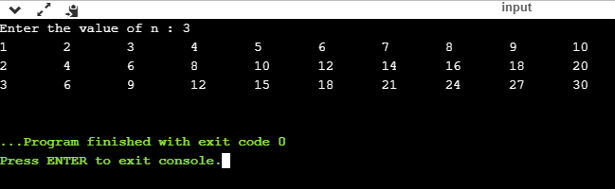

Nested while loop

The nested while loop means any type of loop which is defined inside the 'while' loop.

1. while(condition)
2. {
3. while(condition)
4. {
5. // inner loop statements.
6. }
7. // outer loop statements.
8. }

Example of nested while loop

1. #include <stdio.h>
2. int main()
3. {
4. int rows;  // variable declaration
5. int columns; // variable declaration
6. int k=1; // variable initialization
7. printf("Enter the number of rows :");  // input the number of rows.
8. scanf("%d",&rows);
9. printf("\nEnter the number of columns :"); // input the number of columns.
10. scanf("%d",&columns);
11. int a[rows][columns]; //2d array declaration
12. int i=1;
13. while(i<=rows) // outer loop
14. {
15. int j=1;
16. while(j<=columns)  // inner loop
17. {
18. printf("%d\t",k);  // printing the value of k.
19. k++;   // increment counter
20. j++;
21. }
22. i++;
23. printf("\n");
24. }
25. }

Explanation of the above code.

* We have created the 2d array, i.e., int a[rows][columns].
* The program initializes the 'i' variable by 1.
* Now, control moves to the while loop, and this loop checks whether the condition is true, then the program control moves to the inner loop.
* After the execution of the inner loop, the control moves to the update of the outer loop, i.e., i++.
* After incrementing the value of 'i', the condition (i<=rows) is checked.
* If the condition is true, the control then again moves to the inner loop.
* This process continues until the condition of the outer loop is true.

Output:

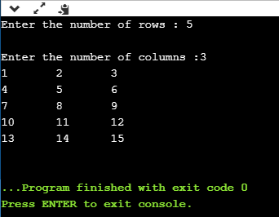

Nested do..while loop

The nested do..while loop means any type of loop which is defined inside the 'do..while' loop.

1. do
2. {
3. do
4. {
5. // inner loop statements.
6. }while(condition);
7. // outer loop statements.
8. }while(condition);

Example of nested do..while loop.

1. #include <stdio.h>
2. int main()
3. {
4. /*printing the pattern
5. ********
6. ********
7. ********
8. ******** */
9. int i=1;
10. do           // outer loop
11. {
12. int j=1;
13. do       // inner loop
14. {
15. printf("*");
16. j++;
17. }while(j<=8);
18. printf("\n");
19. i++;
20. }while(i<=4);
21. }

Output:

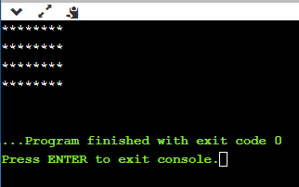

Explanation of the above code.

* First, we initialize the outer loop counter variable, i.e., 'i' by 1.
* As we know that the do..while loop executes once without checking the condition, so the inner loop is executed without checking the condition in the outer loop.
* After the execution of the inner loop, the control moves to the update of the i++.
* When the loop counter value is incremented, the condition is checked. If the condition in the outer loop is true, then the inner loop is executed.
* This process will continue until the condition in the outer loop is true.

# Infinite Loop in C

## What is infinite loop?

An infinite loop is a looping construct that does not terminate the loop and executes the loop forever. It is also called an indefinite loop or an endless loop. It either produces a continuous output or no output.

## When to use an infinite loop

An infinite loop is useful for those applications that accept the user input and generate the output continuously until the user exits from the application manually. In the following situations, this type of loop can be used:

* All the operating systems run in an infinite loop as it does not exist after performing some task. It comes out of an infinite loop only when the user manually shuts down the system.
* All the servers run in an infinite loop as the server responds to all the client requests. It comes out of an indefinite loop only when the administrator shuts down the server manually.
* All the games also run in an infinite loop. The game will accept the user requests until the user exits from the game.

We can create an infinite loop through various loop structures. The following are the loop structures through which we will define the infinite loop:

* for loop
* while loop
* do-while loop
* go to statement
* C macros

### For loop

Let's see the infinite 'for' loop. The following is the definition for the infinite for loop:

1. for(; ;)
2. {
3. // body of the for loop.
4. }

As we know that all the parts of the 'for' loop are optional, and in the above for loop, we have not mentioned any condition; so, this loop will execute infinite times.

Let's understand through an example.

1. #include <stdio.h>
2. int main()
3. {
4. for(;;)
5. {
6. printf("Hello javatpoint");
7. }
8. return 0;
9. }

In the above code, we run the 'for' loop infinite times, so "Hello javatpoint" will be displayed infinitely.

Output

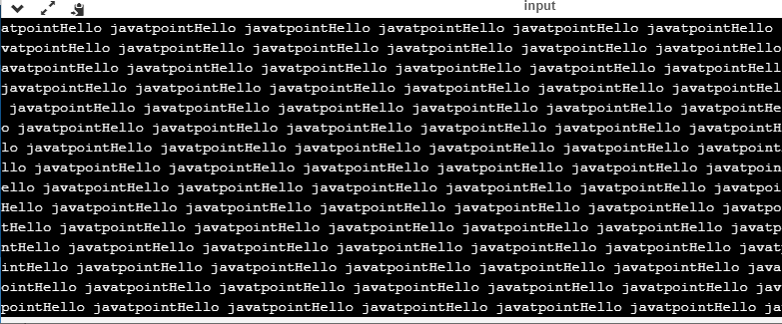

### while loop

Now, we will see how to create an infinite loop using a while loop. The following is the definition for the infinite while loop:

1. while(1)
2. {
3. // body of the loop..
4. }

In the above while loop, we put '1' inside the loop condition. As we know that any non-zero integer represents the true condition while '0' represents the false condition.

Let's look at a simple example.

1. #include <stdio.h>
2. int main()
3. {
4. int i=0;
5. while(1)
6. {
7. i++;
8. printf("i is :%d",i);
9. }
10. return 0;
11. }

In the above code, we have defined a while loop, which runs infinite times as it does not contain any condition. The value of 'i' will be updated an infinite number of times.

Output

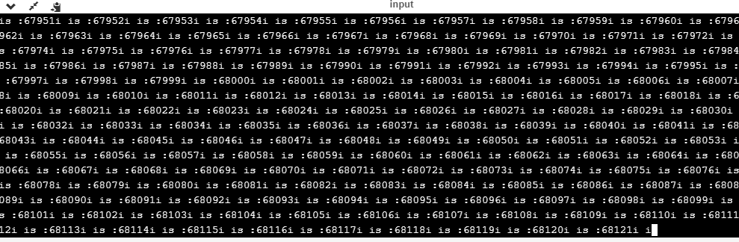

do..while loop

The do..while loop can also be used to create the infinite loop. The following is the syntax to create the infinite do..while loop.

1. do
2. {
3. // body of the loop..
4. }while(1);

The above do..while loop represents the infinite condition as we provide the '1' value inside the loop condition. As we already know that non-zero integer represents the true condition, so this loop will run infinite times.

goto statement

We can also use the goto statement to define the infinite loop.

1. infinite_loop;
2. // body statements.
3. goto infinite_loop;

In the above code, the goto statement transfers the control to the infinite loop.

Macros

We can also create the infinite loop with the help of a macro constant. Let's understand through an example.

1. #include <stdio.h>
2. #define infinite for(;;)
3. int main()
4. {
6. infinite
7. {
8. printf("hello");
9. }
11. return 0;
12. }

In the above code, we have defined a macro named as 'infinite', and its value is 'for(;;)'. Whenever the word 'infinite' comes in a program then it will be replaced with a 'for(;;)'.

Output

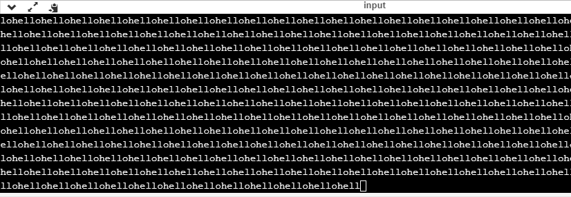

Till now, we have seen various ways to define an infinite loop. However, we need some approach to come out of the infinite loop. In order to come out of the infinite loop, we can use the break statement.

Let's understand through an example.

1. #include <stdio.h>
2. int main()
3. {
4. char ch;
5. while(1)
6. {
7. ch=getchar();
8. if(ch=='n')
9. {
10. break;
11. }
12. printf("hello");
13. }
14. return 0;
15. }

In the above code, we have defined the while loop, which will execute an infinite number of times until we press the key 'n'. We have added the 'if' statement inside the while loop. The 'if' statement contains the break keyword, and the break keyword brings control out of the loop.

Unintentional infinite loops

Sometimes the situation arises where unintentional infinite loops occur due to the bug in the code. If we are the beginners, then it becomes very difficult to trace them. Below are some measures to trace an unintentional infinite loop:

* We should examine the semicolons carefully. Sometimes we put the semicolon at the wrong place, which leads to the infinite loop.

1. #include <stdio.h>
2. int main()
3. {
4. int i=1;
5. while(i<=10);
6. {
7. printf("%d", i);
8. i++;
9. }
10. return 0;
11. }

In the above code, we put the semicolon after the condition of the while loop which leads to the infinite loop. Due to this semicolon, the internal body of the while loop will not execute.

* We should check the logical conditions carefully. Sometimes by mistake, we place the assignment operator (=) instead of a relational operator (= =).

1. #include <stdio.h>
2. int main()
3. {
4. char ch='n';
5. while(ch='y')
6. {
7. printf("hello");
8. }
9. return 0;
10. }

In the above code, we use the assignment operator (ch='y') which leads to the execution of loop infinite number of times.

* We use the wrong loop condition which causes the loop to be executed indefinitely.

1. #include <stdio.h>
2. int main()
3. {
4. for(int i=1;i>=1;i++)
5. {
6. printf("hello");
7. }
8. return 0;
9. }

The above code will execute the 'for loop' infinite number of times. As we put the condition (i>=1), which will always be true for every condition, it means that "hello" will be printed infinitely.

* We should be careful when we are using the break keyword in the nested loop because it will terminate the execution of the nearest loop, not the entire loop.

1. #include <stdio.h>
2. int main()
3. {
4. while(1)
5. {
6. for(int i=1;i<=10;i++)
7. {
8. if(i%2==0)
9. {
10. break;
11. }
12. }
13. }
14. return 0;
15. }

In the above code, the while loop will be executed an infinite number of times as we use the break keyword in an inner loop. This break keyword will bring the control out of the inner loop, not from the outer loop.

* We should be very careful when we are using the floating-point value inside the loop as we cannot underestimate the floating-point errors.

1. #include <stdio.h>
2. int main()
3. {
4. float x = 3.0;
5. while (x != 4.0) {
6. printf("x = %f\n", x);
7. x += 0.1;
8. }
9. return 0;
10. }

In the above code, the loop will run infinite times as the computer represents a floating-point value as a real value. The computer will represent the value of 4.0 as 3.999999 or 4.000001, so the condition (x !=4.0) will never be false. The solution to this problem is to write the condition as (k<=4.0).